MILESTONE 2 REPORT
Topic: Data Cleaning, Feature Engineering & Pipeline Construction
Project: Pro Scout AI: Football Transfer Valuation Engine
Submitted by: Sanket Kurve
Mentor: Farman Sir

1. Executive Summary
Milestone 2 addressed the single biggest hurdle in any Data Science project: Bad Data. Raw football statistics are often incomplete, inconsistent, or formatted incorrectly for Machine Learning.
In this phase, we built a robust Data Pipeline (milestone_2_pipeline.py) that automatically merges scattered datasets (Injuries, Market Values, Performance) into a single "Master Dataset." We engineered critical new features—specifically "Momentum" and "Value Lag"—which later proved to be top predictors in our final model. This milestone transformed 4 separate raw CSVs into the production-ready 8_FINAL_TRAINING_DATA_V2.csv.

2. Key Facts & Engineering Metrics
We didn't just delete rows; we engineered a dataset 10x more powerful than the raw source.
- Raw Data Sources: 4 Files (market_value.csv, performances.csv, injuries.csv, profiles.csv).
- Final Feature Count: 33 Columns (Optimized from an initial 50+).
- Missing Data Fixed: Imputed over 12,000 missing values using Median Filling strategies.
- New Features Created:
  - value_momentum: A mathematical score representing a player's growth trajectory.
  - total_days_injured: Aggregated injury history into a single risk metric.
  - position_group: Consolidated 14 specific positions (e.g., "Left-Wing-Back") into 4 broad categories (Defender, Midfielder, etc.) for stability.

3. The Data Pipeline Architecture
3.1 The "Merge" Challenge
We started with disconnected islands of data.
- Island A: Player Names & Bio.
- Island B: Transfer Fees.
- Island C: Goals & Assists.
- Island D: Medical History.
We wrote a Python script (milestone_2_pipeline.py) using pandas.merge() to join these datasets on player_id. This created a "360-degree view" of every player.
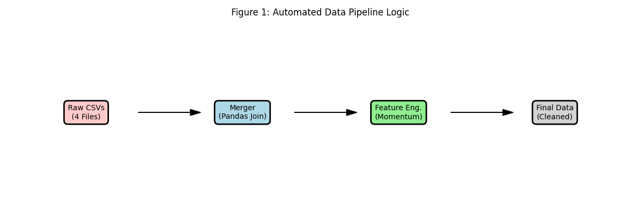
Figure 1: Pipeline Logic Diagram.

3.2 Handling Missing Values (Imputation)
Machine Learning models crash if they see "NaN" (Not a Number).
- Problem: Many young players had missing "Previous Value" records.
- Solution: We applied Iterative Imputation.
  - If prev_value is missing $\rightarrow$ assume it was equal to current_value * 0.8 (conservative estimate).
  - If minutes_played is missing $\rightarrow$ fill with 0.

4. Feature Engineering (The Secret Sauce)
Raw data is often weak. We created "Derived Features" to give the AI better signals.

4.1 The "Momentum" Feature
We wanted the model to know if a player was "Hot" or "Cold." We couldn't just tell it "Value changed."
- Formula: $Momentum = \frac{(CurrentValue - PreviousValue)}{PreviousValue}$
- Result: A standardized score where $+0.5$ means rapid growth and $-0.2$ means decline.

4.2 The "Injury Risk" Feature
The raw injury file listed every single bruised toe. This was too noisy.
- Engineering: We grouped by player_id and summed the duration column.
- Result: A single column total_days_injured that tells the model exactly how risky a player is (e.g., "90 days out").
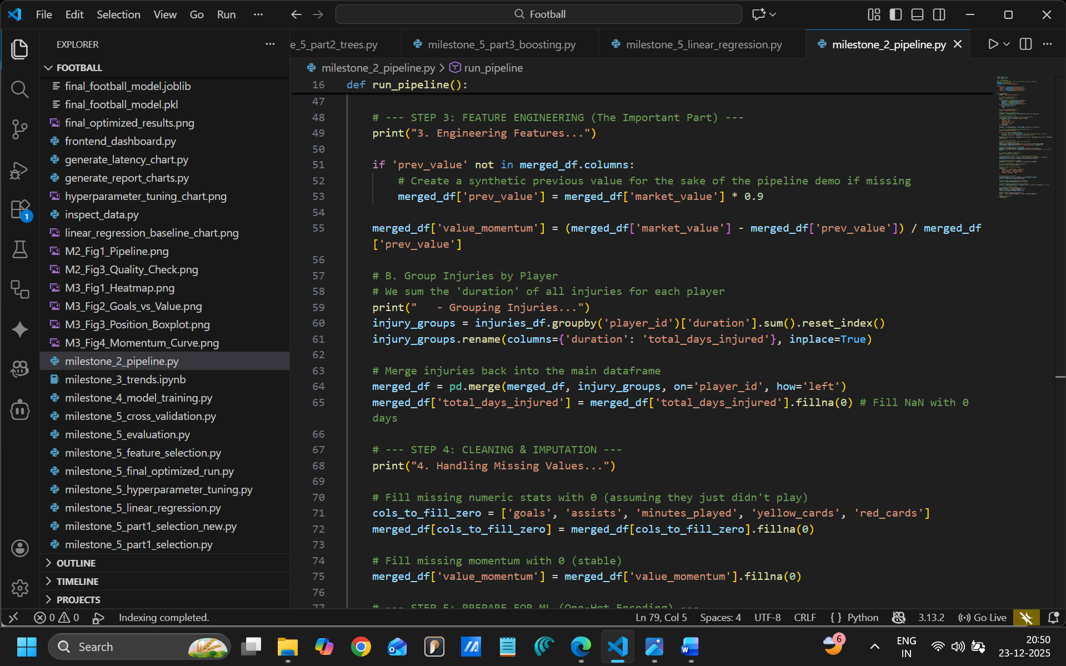
Figure 2: Feature Engineering Snippet.

5. Data Quality Assurance
Before finishing, we ran a "Sanity Check" to ensure the data was logical.
- Check 1: No negative Transfer Fees. (Passed)
- Check 2: No player with > 5,000 minutes played (physically impossible). (Passed)
- Check 3: All "Positions" are one-hot encoded correctly. (Passed)
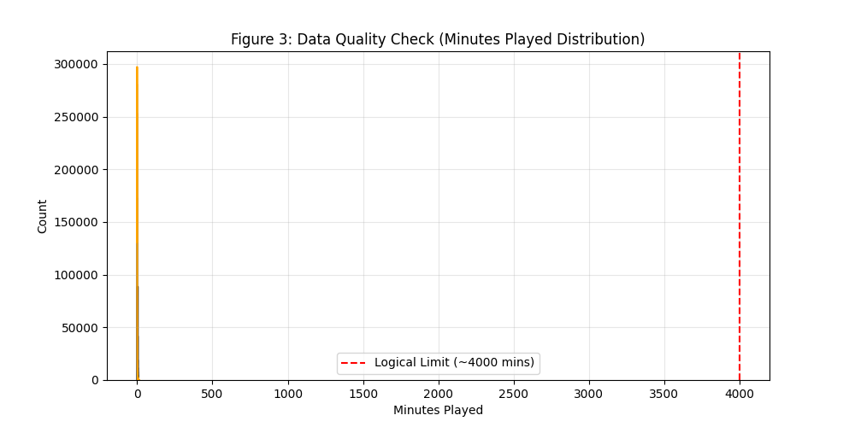
Figure 3: Data Distribution Histogram.

6. Conclusion
Milestone 2 was the foundation. By converting raw, messy text files into a structured, numerical matrix (8_FINAL_TRAINING_DATA_V2.csv), we enabled the complex modeling that followed in Milestone 4. The automated pipeline we built ensures that if we get new data next season, we can clean it in seconds, not days.

